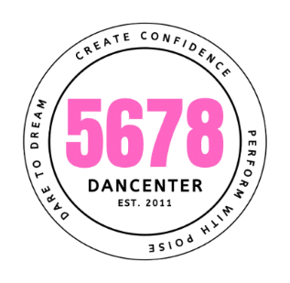

Summer Camp Registration Form

Name of Camp attending_______________________________

Camper’s name_____________________________________________

Camper’s address___________________________________________

Campers Age ___________

Parent’s name and contact information Name_____________________________________________________

Address___________________________________________________

Phone Number_____________________________________________

Email Address ______________________________________________

Please list below any allergies or health issues that we need to have on file for your child____________________________________________

__________________________________________________________

I give my permission for __________________ to attend the above camp with 5-6-7-8 Dancenter ___________________ Parent’s signature

My child’s picture at camp can be used for our social media page on Face Book Yes No. please circle one. Yes No

I will need childcare after camp ends. Yes No Please circle one

**Campers must bring their own snacks and drinks for camp. If a camper is staying for the day, they must bring their lunch.**